# Configure SSH Access to your Virtual Machine

To ssh into your virtual machine follow the instructions you received per email from [cloud@switch.ch](mailto:cloud@switch.ch) (Subject: *[SWITCHengines] Login information for* ***your_user_name@your_ip***)

Once your ssh access works, there are a few more custom steps we need to take before we can use Confluent Kafka (Note: all instructions below assume your shell is bash. That is not the default shell if you use **MobaXTerm**. Simply type bash in the command prompt to start a new bash shell)

# Configure Port Forwarding

We need to configure forwarding of two local ports - 9021 and 8088 - to the corresponding ports on the remote machine. If you already know how to do this, skip the following instructions and move to the next step.

## Windows (MobaXTerm)

1. Click on **Tools -> MobaSSHTunnel (port forwarding)**
2. Click on **New SSH tunnel**
3. Fill the pop-up window in the way shown on the right figure. This configures port 8088.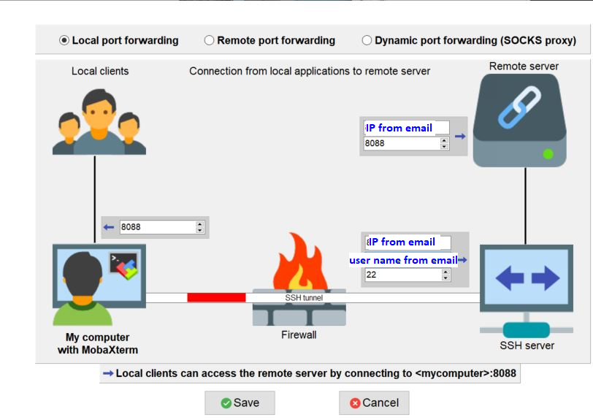
4. Repeat steps 2. and 3. For port 9021
5. At the end configure the same ssh key for the tunnels as you used for ssh log-in. Click on the icon illustrating a key and select the private key file for each of the two ports.
6. Don’t forget to start the forwarding process. Click on the icon with a play symbol on it for both ports.

## Linux (or MacOS):

If you are using Linux (or MacOS) you should already know how to do this. If not, consider improving your Linux skills or move to something simpler, like Windows :)

Port forwarding can be easily configured by modifying the ssh command used to log-in:

ssh -L 9021:localhost:9021 -L 8088:localhost:8088 -i ~/.ssh/**your_private_key** **your_user_name**@**ip_address_from_email**

# Configure hosts file

We need to instruct your operating system to resolve the name confluence-kafka to the ip address of your virtual machine.

## Windows

Edit the file **C:\Windows\System32\drivers\etc\hosts** as an administrator and add the following line at the end:

**IP_address_from_email confluence-kafka**

Note, there is a space between the ip address and confluence-kafka

## Linux (or MacOS)

Edit the file **/etc/hosts** with superuser privileges and add the following line at the end

**IP_address_from_email confluence-kafka**

Note, there is a space between the ip address and confluence-kafka

# 

# Get started for real

With the above setup successfully completed you can now log-in to your cloud machine and start Confluent Kafka. Don’t forget to make sure you are running **bash** as your shell.

# Start Confluent Services

Upon first log-in to the cloud instance, the Confluent-Kafka services need to be restarted. Follow the following steps.

1. Stop all confluent-kafka services:

**sudo systemctl stop confluent-control-center.service && sudo systemctl stop confluent-kafka-connect.service && sudo systemctl stop confluent-kafka-rest.service && sudo systemctl stop confluent-ksqldb.service && sudo systemctl stop confluent-schema-registry.service && sudo systemctl stop confluent-server.service && sudo systemctl stop confluent-zookeeper.service**

1. Start all confluent-kafka services in the right order:

**sudo systemctl start confluent-zookeeper.service && sudo systemctl start confluent-server.service && sudo systemctl start confluent-kafka-connect.service && sudo systemctl start confluent-kafka-rest.service && sudo systemctl start confluent-ksqldb.service && sudo systemctl start confluent-schema-registry.service && sudo systemctl start confluent-control-center.service**

1. Wait a few moments, it will take up to a minute for all services to start
2. Make sure that all confluent-kafka services are running properly:

**systemctl list-units confluent\***

If a **confluent-\*** service is not running then try to explicitly restart it:

**sudo systemctl restart <service_name>**

# Connect to Confluence Control Center

If all services are running properly then point your browser to **localhost:9021** to open the Confluent server UI.

If the UI is not running or displaying warnings or errors, wait a few minutes until all services have successfully started.

That’s it. You now have the basic setup to start your Kafka learning experience. We will take it from here in the lecture.

# Troubleshooting

## Confluent services persistently fail to start

One common underlying issue may be that your machine is running out of space. Try removing old log files (these can become very large):

**sudo su**

**cd /var/log/kafka**

**ls -lh**

Look for large old files and remove them by **rm <file_name>**

Try restarting the services again.